# **Insurance Domain User Stories**

**Project Name – GPHI** (Global Principal Heath Insurance)

**End User / Policy holder**

**Insurance companies** – TATA, HDFC, SBI, ICIC, etc

* **How User Stories Looks Like In JIRA :**

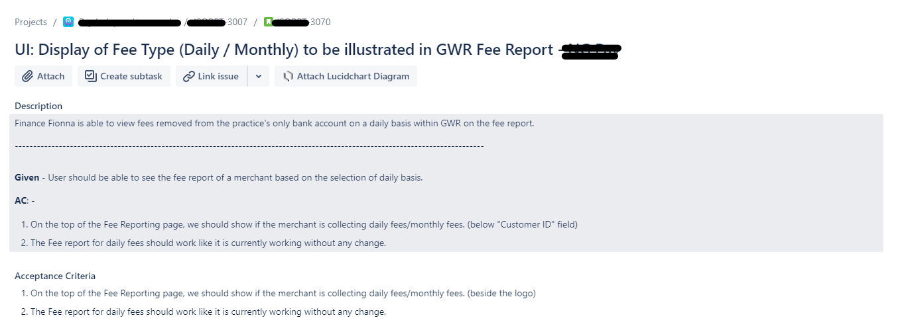

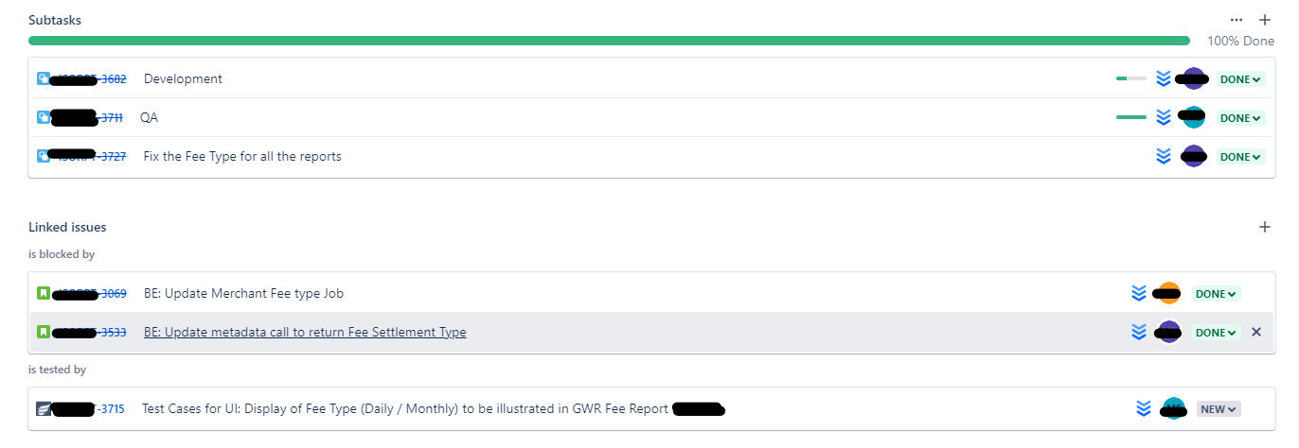

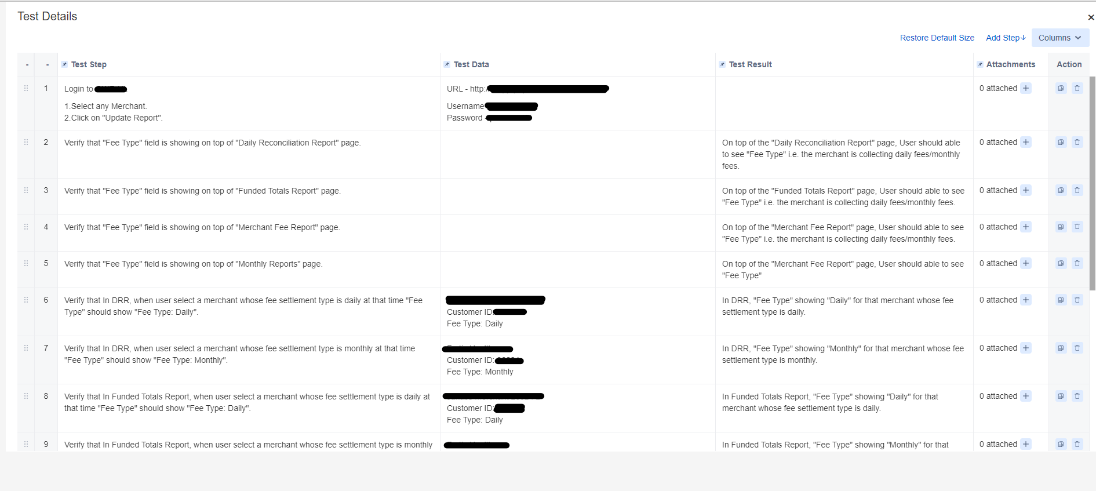

# **Manual Testing:-**

# **IDP 1111 - UI : Life Insurance Module - Different Plans**

**Description** – Health insurance plan offers financial coverage against the fixed amount of premium for a specific term. If the insured person dies during the policy term, a death benefit is paid to the insured person's family. Term plan provides high cover at low premium rates which helps in fulfilling the future requirements of your family in case of your absence.

**Acceptance criteria -**

1. New grid of plane shows all data per screen shows **FRS / SRS.**
2. Grid will show data as per **Insuere (Filter)**, **Life Cover(Drop Down)**, **Cover till age (Drop Down)**, **Claim Settled (Asc & Desc)**, **Pay Monthly/Pay Yearly (Toggle button).**
3. Life cover wedge will open a pop up for values with amount filed text box (drop down / custom values)
4. Amount drop down / custom values pop will shows 20LPA to 20Cr
5. Life cover will open pop will shows “Recommended Life Cover” (as per DB - top 5 or 10)
6. Plans data will comes from main tables - “dim.inc_detail”

**Test Cases -**

* 1. Verify that Insurer Filter is present on that page or not, Spelling is right or wrong.
  2. Verify that Insurer Filter is clickable or not
  3. Verify that after click on Insurer Filter button the Filer Pop Up window showing or not
  4. Verify that Min value for Life Cover is 20 Lakh and Max Value for Life Cover is 20Cr
  5. Verify that End user can add custom values or not.
  6. Verify that When we select a particular amount it shows planes related to that amount